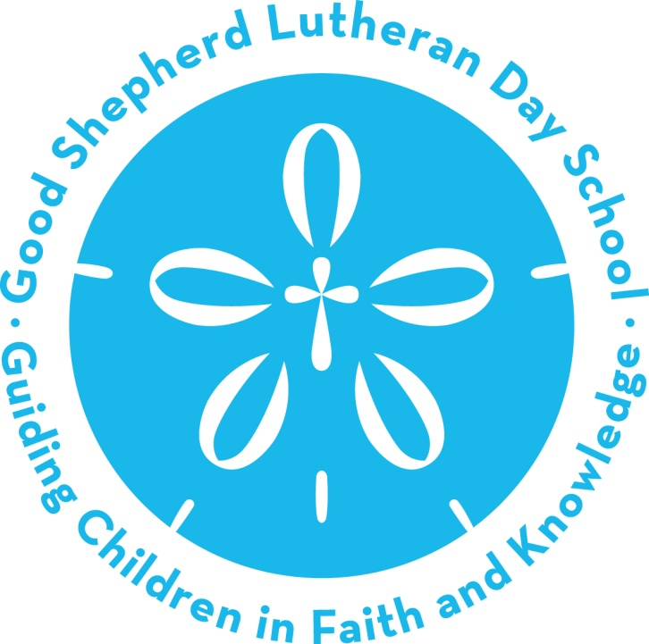

~Curriculum Guide~

***“Guiding Children in Faith and Knowledge”***

501 S. Dale Mabry Highway

Tampa, FL 33609

Tel: 813-870-2573

Fax: 813-876-2168

Email: gsds.director@gmail.com

Please visit: www.GSDaySchool.com

*Mission Statement*

Good Shepherd Lutheran Church Day School’s mission is to serve God and our country by teaching and practicing the values that are important for being a successful, spiritual and intellectual member of our 21st century society. We will achieve this by providing high quality education and care appropriate to each child’s unique personality, learning style, and family culture in a beautiful, loving and nurturing Christian environment.

*Vision Statement*

The school is part of the Good Shepherd Lutheran Church’s youth ministry outreach. Our vision is to aspire to create a place where children, families and staff are excited to come to every day. We want all our constituents to find that they can grow physically, cognitively, spiritually, creatively, socially and aesthetically in multiple ways that allow for individuality in a warm, nurturing, responsive and beautiful environment.

**A People Place**

If this is not the place where tears are understood, where do I go to cry?

If this is not a place where my spirits can take wing, where do I go to fly?

If this is not a place where my questions can be asked, where do I go to seek?

If this is not a place where my feelings can be heard, where do I go to speak?

If this is not a place where you’ll accept me as I am, where can I go to be?

If this is not a place where I can try to and learn to grow, where can I just be me?

-William J. Crocker

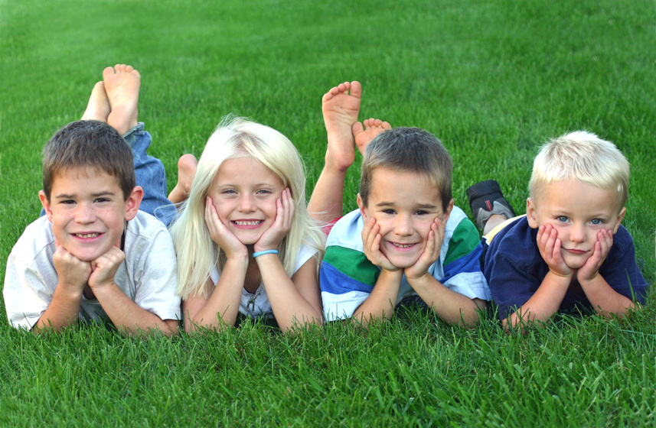

*Our Values*

Values are the principles that guide and drive our behavior. When we actively engage with values, we start to understand their implications in the choices we make, the responses we have for situations that arise, and our attitudes about living and learning.

Incorporating values into an early education program encourages self-reflection about our attributes and attitudes. By using values as our guide, high quality education and experiences happen at all levels of the school. Children have better learning outcomes across all domains (academic, intellectual, social/emotional, physical, spiritual and aesthetic). Relationships are transformed for students, families, staff, and visitors to encourage connection, communication and collaboration. Having values at the base increases staff professionalism and commitment and increases parent engagement in their children’s schooling. When we nurture positive attributes and attitudes, children, families and staff discover the very best of themselves.

The following values serve as the guide for us at Good Shepherd Day School.

***We value Faith***:

Primarily, we are energized by God’s love for all people. From that primary inspiration grows the vision we must give every child an early start in learning about the Christian faith and its values to build a self-confident, loving and moral child and future-adult.

***We value Childhood***:

Children come first at Good Shepherd Day School. We recognize that childhood is a special time during a person’s life. Childhood should be respected and rejoiced! We will always be a school that understands this fundamental truth and will make sure that making a happy childhood is at the heart of everything we do. We strive to preserve childhood.

***We value Learning and Intellectual Curiosity***:

God created humans to be curious about the world- to wonder, question, and explore possibilities. All children have a deep desire and drive to learn because they are curious about the world they live in. We must support this curiosity and provide as many resources as possible in as many ways as possible to satisfy this drive. Classrooms are rich with books and other materials to support this.

***We value Creativity***:

Creativity is not about art, although art is commonly what we think about. Creativity is about identifying a problem and then coming up with solutions to address the problem. Creativity happens when you are writing, speaking, working on a math problem, trying to understand how to build or design something, how to work with another person, how to understand why something you see in the world is happening, and on. As a society, we value progress and innovation, both of which are rooted in creativity. Using higher level thinking skills that are part of the creative process is as important as academics in our 21st century world.

***We value Character***:

Having a good character is a value that is often overlooked or forgotten when thinking about education. Having a good character that involves honesty, integrity, compassion, dependability, determination, and many more are what defines success in all parts of a person’s life. We encourage character development in the children and the adults in our program.

***We value Community and Family***:

Families find Good Shepherd Day School has a strong sense of community. We strive to have a family-feel to our school, like a second neighborhood, where families gather to chat about their children and exchange interesting events in the community. Families are encouraged to share their interests with their child’s classroom. Family portraits of every child are displayed in every room. Warm, homey colors and touches decorate the rooms. Each classroom “family” organizes events for the whole school on a regular basis to bring everyone together in celebration. With a strong sense of family and community, children feel supported in their learning and find joy coming to school every day!

***We value Communication***:

Communication at all levels is the “grease” that makes things happen at Good Shepherd. From weekly email updates from the staff and administration, to hand-written notes, to parent meetings, we try our very best to make sure everyone is heard, responded to, and informed. Lesson plans let parents understand what is happening in the classroom and how they can support the school at home. Documentation boards provide visual evidence of the children’s hard work. Bi-annual conferences with parents make sure that home-school communication about child goals is in place.

Children value communication too, so we pride ourselves in having a very strong early literacy focus at our school for all children, with daily opportunities to speak, listen, write, and read. Our goal is to make sure that every child who leaves for Kindergarten is proficient in early literacy skills to start them off for a life of communication with others.

***We value Growth***:

Change- it is part of growth. Taking the butterfly life cycle as a metaphor for the process of change and growth, it is natural and it is a good thing! Children grow- not always at the same time, just like all caterpillars do not transform on the same day. We respect the process of growth and lay a nurturing foundation with families to ensure it happens for all children. Good Shepherd Day School also grows, making changes and adjustments over time to reach our goals of being one of the most outstanding early childhood centers in Tampa Bay!

***We value Knowledge***:

Valuing knowledge is common for all schools. However, what we especially value at Good Shepherd Day School is knowledge that comes from deep exploration and study. Therefore, you will see our children spend anywhere from two weeks to a month or more investigating certain topics throughout the year. Using a “Project Approach” sets us apart from many schools who use weekly themes that only allow children to learn about something superficially. The staff are also encouraged to deepen their knowledge with annual training and on-going study about child development and curriculum development.

***We value our Environment***:

When we talk about “environment” at Good Shepherd, we think of it in two ways. First, is the common way most people think about it, in terms of nature. Our EdVenture family trips, school garden areas, classroom animals, classroom decor, natural toys and in-depth project work expose children to the beauty of the world God created and how important it is to care for His creations.

Second, is the way we also speak of “environment” when we talk about our classrooms and other spaces for children. Maintaining a healthy, safe and stimulating learning environment is accomplished through routine health and safety checks and a heavy investment in toys and other learning equipment. We are inspired by the beauty of nature to make our classrooms places of beauty that bring calmness and peace to everyone.

***We value Collaboration***:

None of our values can be implemented without the power of many people working together for common goals. There are different ways for families and staff to collaborate: individual meetings with families, Friends of Good Shepherd group, and serving on our Board. We discuss issues, set goals and carry out plans for the common good of everyone at Good Shepherd. Even the children are encouraged to collaborate on projects, such as planning a feast, planning a garden, or creating a mural together.

***We value Individuality***:

God made no two people alike. It is with this simple idea that we respect the individuality of everyone who participates at our school. Different faiths, ethnicities, and family-make-ups enroll their children at Good Shepherd because we respect everyone’s choice of how they bring love, faith, and happiness to their lives. We also respect that no two children are the same or will develop in the same way. God has a plan for each child, and our challenge is to make sure that every child has the best foundation as possible for their life’s work! We respect the individuality of our parents as people who are doing the best they can for their children and the individuality of our staff who bring a variety of experiences and ideas to the wonderful place that is Good Shepherd Day School.

*Guiding Educational Philosophy: Children Are Powerful and Unique*

The philosophy that guides the staff of Good Shepherd Day School is built on respect for the uniqueness of each child and each family. Every child is hard at work: curious, watching, imitating peers and adults, exploring with all senses, experimenting socially, physically, and intellectually, and constructing her and his understanding of the world. Parents and educators are the roots and the branches providing support.

**Individual development happens over time.**A person’s growth in social, emotional, kinesthetic, linguistic, logic, mathematical, existential, and musical domains isn’t synchronized.  These multiple intelligences blossom in various directions at different times.  Some children develop physically very quickly, while others spend more time telling stories. All domains become better balanced over time if we nurture the whole child.

**Three teachers, 1- the parents, 2- the educators, and 3- the environment enable development**.  The quality of our relationships and the stimulations in the environment supports growth. Our duty starts with observing, listening, and sharing the questions.  Then we provide a carefully prepared environment filled with proper tools to remove barriers, open access, and allow the children to think and create.  That is how we empower children to understand, self-regulate, and innovate.

*How Reggio Emilia Influences our Program*

We draw our primary educational inspiration from the educators of Reggio Emilia, Italy, whose world renowned educational philosophy is based on the work of educational theorists such as Lev Vygotsky, Jean Piaget, Maria Montessori, Loris Malaguzzi, Howard Gardner and Magda Gerber. These theorists guide our thinking about the different ways in which children learn and affect the choices we make for how we implement our curriculum. We do not believe that any pre-packaged, commercial curriculum will ever be as flexible and responsive as the matrix of theories that are incorporated into the Reggio Emilia approach.

The fundamental idea of the Reggio Emilia approach is their unique **view of the child**. While most preschool programs view the child as an “empty vessel,” a major tenet of the Reggio Approach is that the **child is capable, curious and interested in subjects worthy of exploring deeply**. The child communicates his/her interests and queries through observations, conversations, discussions and choices. There is constant **collaboration between the teacher, child, and parent**. The teacher serves as a partner, supporter and guide to help the child, or group of children, follow their interests on an inquiry. Children develop problem-solving skills as teachers help refine children’s hypotheses and theories. Parents support this process as well as they share ideas and skills that support the learning taking place in the classroom. The Reggio Emilia Approach celebrates the joy in discovery and it prepares children to be creative, self-confident learners and citizens.

**Classroom Environment:**  The Reggio Emilia Approach places an emphasis on the classroom environment and considers the **environment as an additional teacher**. It encourages the use of the outdoors and believes it is essential to bring the natural world into the classroom. There is also particular attention placed on aesthetic awareness.

**Documentation:**  Teacher documentation is an **assessment tool**that also informs instructional and curricular decisions.  Learning is made visible and communicated to the community (parent, child, teachers) through **documentation**that represents the children’s investigations. Documentation includes photographs, drawings and other artifacts generated by the children. It also includes the teacher’s commentary on the purpose of the study and the process of learning.

**Multi-Age Classroom Rational:** Multi-age classrooms are well supported in the world of early childhood education. These thoughtful settings invite children to cooperate, exchange ideas and encourage pro-social behavior. Children of varying ages create a multi-dimensional classroom that supports novices and experts. Younger children are more likely to make contributions as they witness an older child’s participation. Older children are given enhanced responsibility as they model skills and create friendships that transcend age. Important cognitive growth occurs when the distance between the actual level of independent problem solving is bridged with the assistance of a teacher or a more capable peer.  In addition, social interaction is a critical precursor for cognitive development. Opportunities for this type of development abound in a multi-age classroom. This structure also provides an opportunity for young children to deepen their bond with their teacher. This is achieved with the potential for teacher/student relationship extending into a second year in our Preschool and Pre-K classrooms, thereby addressing a child’s developmental needs.

**An Inquiry Based Curriculum:**  In a dynamic classroom that embraces the Reggio approach to curriculum, teachers watch and study the class in action, carefully observing the children. Curriculum becomes an adaptive process that engages children and teachers. Throughout the year it is the teacher’s job to determine what idea or theme contains the seed from which a child-sensitive project may emerge. Teachers visit and revisit these topics with their colleagues, as well as with the children in the classroom, to assess if a topic can be sustained while supporting basic skill development.

**The Value of Play:**  We believe that play is an integral part of the school day. Productive, independent play supports children as they attain developmental goals and allows them to take risks in a safe environment. Play is a proven vehicle for children to build the skills they need to be successful in school and beyond. “A study of children from around the world from Indonesia to Italy to Ireland (and the United States), showed that when preschool experiences at age 4 included lots of child-initiated, free-choice activities supported by a variety of equipment and materials - the kinds of environments that support play - these children had better cognitive (and language) performance at age 7 than their peers.” (Copple & Bredekamp 2009)

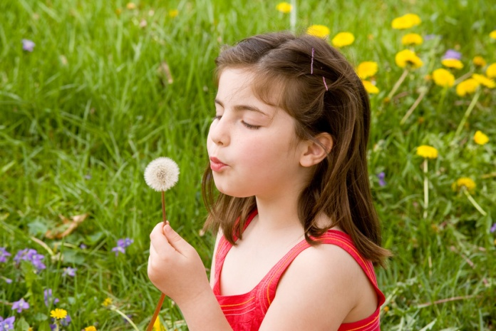

*The National Association for the Education of Young Children (NAEYC)*

The guidelines for our program also come from the National Association for the Education of Young Children’s position statement on Developmentally Appropriate Practice. As NAEYC defines it, *developmentally appropriate practice* (DAP) is a framework of principles and guidelines for best practice in the care and education of young children, birth through age 8. It is grounded both in the research on how young children develop and learn and in what is known about education effectiveness. The principles and guidelines outline practice that promotes young children's *optimal* learning and development. Developmentally appropriate practice is also the foundation for all Good Shepherd Day School’s professional development/training, policy/advocacy. For more about developmentally appropriate practices, please visit: [***www.NAEYC.org***](http://www.NAEYC.org)

*Florida State Standards and National Common Core*

Our curriculum is based on the coming together of our mission, vision, values and educational philosophy. However, we also make sure to address the state and national learning and development recommendations for young children when we plan for curriculum. For more information, please visit:

Florida Birth to Three Standards: <http://www.unf.edu/uploadedFiles/aa/fie/Birthto3%20Standards.pdf>

Florida Early Learning and Developmental Standards for Four Year Olds (VPK Guidelines):

<http://www.fldoe.org/earlylearning/perform.asp>

For more information on the Kindergarten National Core Curriculum Standards, visit:

Kindergarten Common Core Standards:

<http://corecommonstandards.com/kindergarten-standards/>

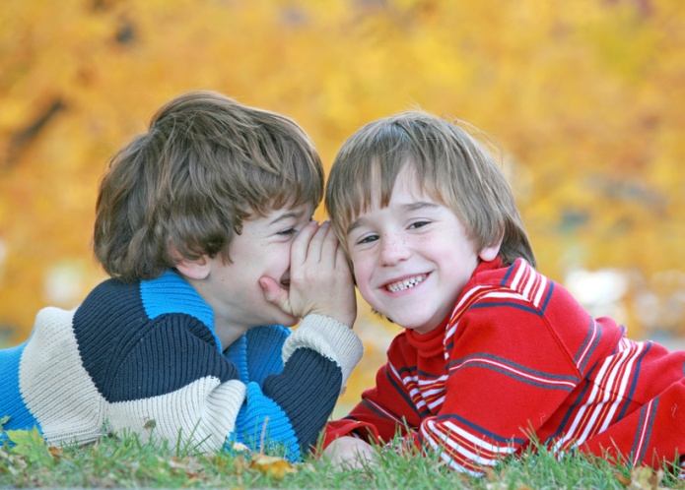

*Traditional Academic Disciplines*

Traditional academic disciplines are taught through child directed exploration times (when children can freely choose where and what to work with), through group times, through project work and through teacher directed 1:1 work.  While not every child wants to work in every area, we trust that over the course of our school year, children will learn skills in each subject area.  Teachers never force or require a child to work on something, however, teachers DO encourage and expect children to stick with decisions that they themselves made, to concentrate and do ones best, and to return to difficult work until it is completed rather than abandoning it.

**Subjects studied include:**

**Literacy**

Comprehension, visual and auditory discrimination, letter and word recognition, fine motor development and phonics are all part of our formal literacy program. Our program uses literature – both popular, classic and up-and-coming – to instill a passion and excitement for books.  Children explore literacy through structured instruction, individual, group and home reading, drama, storyboards, puppets, author study, and throughout other curriculum areas.

**Mathematics**

We use a lot of Montessori inspired math materials and teaching strategies in our program because of the solid foundation that it gives children. Children learn numerical symbols and amounts, patterns, graphing, charting, classification, currency, time, spatial reasoning and problem solving in a hands-on way.

**Geography and Social Studies**

Continents, countries, cities, landforms, water bodies: there is so much to study in our world! Hands-on materials are used to supplement learning about our world, as are research materials such as National Geographic magazines, books and the internet. Children learn about the diversity of the world around them through celebrating families, cultures and traditions, starting with our own, then extending out to what others may do. We value each child as a unique individual and as a member of our group. We foster an appreciation of multi-cultural art, music and literature in a hands-on way.

**Engineering & Architecture**

Spatial reasoning, determining how things work, having a vision and determining how to make that vision a reality are all skills architects and engineers use daily.  Focus is on the vision-design-create process.

**Science & Technology**

A curious mind and understanding of the world are taught through the scientific method: ask a question, create a hypothesis, test, observe, and draw a conclusion.  Children will study areas in biology, physics, chemistry, geology, zoology and technology.  Technology tools – with secure and safe internet access – are used for further research and exploration.

**Performing Arts**

Our performing arts program has three main components: dance, drama & music, all of which encourage self-expression, confidence and body awareness.  Children enjoy movement, music, and rhythm and learn balance, strength, flexibility and coordination.  Our ever-changing offering of costumes and props is a magical and surprising part of our program.

**Visual Arts**

Children are inspired to try new techniques and to explore what they can create through a wide variety of visual media- clay, paper, light, shadow, paint, collage.  Through the “language” of art our children express their ideas about the world around them while they practice fine motor and visual discrimination skills, an important foundation for learning how to read.

**Physical Education**

Large and fine motor skills, coordination and balance are learned through physical fitness activities that develop strong, healthy and coordinated bodies.  Outdoor gross motor activities on our richly equipped playground builds the foundation for healthy lifelong fitness habits.

**Social Development**

Social graces and etiquette are a part of character education, and are an important part of our program.  The classroom supports the development of social graces such as saying “Please” and “Thank you”, setting a table, table manners, cleaning up after oneself, shaking hands and making eye contact.

We also place a strong emphasis on group social skills: a significant portion of our curriculum focuses on developing problem solving skills with peers, negotiating difficult situations, learning to share and take turns, and working with different people, in both leadership and team roles. In fact, current research is showing that self-regulation, an important social-emotional skill, has a stronger association with academic achievement than traditional math skills or even IQ levels!  Without strong social-emotional skills, we have found that children are simply not able to participate effectively or independently in self-directed group learning.  As a result, a significant portion of our program time is aimed at helping children develop social-emotional skills.

*The Project Approach: The Framework for Putting It All Together*

Good Shepherd Day School believes that there is a need to acquire traditional skills in context: learning can best occur when it is relevant to the child and their life. Study material should spark excitement for learning, emphasize fun found in acquiring new information and skills, and allow for individual expression.

Addressing these needs, our curriculum extends beyond the boundaries of traditional disciplines. For the child to receive a significant, relevant and challenging education, the child must be able to reflect on the connections between their life in school, home and the world.

In each of our classrooms, children discover that learning is connected to “real” life, thus establishing a strong basis for future learning and education. To understand this connection, the classroom community of students and teachers work together exploring in-depth projects.

Projects do not always have a set time frame but rather evolve through a negotiation between children and teachers. Skilled teachers work to provoke deep thinking and questioning, which often prolongs an interest. Teachers do know that projects will inevitably lead to a holistic learning experience, and that they will easily be able to integrate our curriculum learning areas into the project work throughout the school year.

Project work is also quite free-flowing: For example, in March, the topic of **Beauty** and **God’s Beauty Is All Around** will have the children exploring the arts, both natural and man-made. Children might explore color theory with different kinds of media: paint, playdough, light, water, etc. They would read books about color, learn to recognize colors, write color names, count things in the classroom of a certain color, graph their favorite colors, eat different colored foods, sing songs about color, dance with colored wands and scarves, plant flowers of different colors, inquire about how the eye sees color, talk about the “sound” different colors make, write stories about color, bring in items from home that are a certain color, and on and on! What a dynamic and stimulating way to teach and learn!

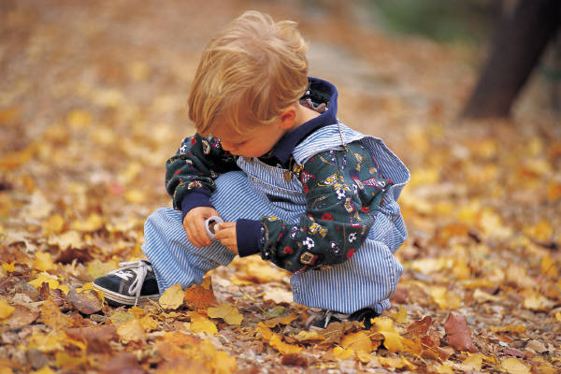

**“It is the supreme art of the teacher to awaken joy in creative expression and knowledge.”**

**-Albert Einstein**

*Monthly Project Topics*

The following is a general outline for the entire school that ties topics and of intellectual study to our faith. These are ***suggested topics*** and may be changed to coincide with both the liturgical season and children’s interests in the world around them:

**August-September**: Me and Others In My World: **God Loves Me!**

**October: Feelings**- Mine and Others: **God Stands By Me, No Matter What!**

**November**: A Bountiful Harvest: **God** **Provides For Me!**

**December:** Acts of Love and Giving to Others: **God Wants Me To Give To Others**

**January:** Our Weather: **Trust In God Through All Kinds Of “Weather”**

**February:** Friendship: **God Says To Be A Friend**

**March:** Beauty: **God’s Beauty Is All Around**

**April:** Animals: **All Creatures Great and Small, God Created Them All**

**May:** Transportation: **No Matter Where You Go, God Is With You!**

These projects focus on developing inquiry and research skills, working with peers and negotiating differences, expressing individual experiences and appreciating other personal and cultural perspectives. Through an in-depth, immersed study of each project, education expands beyond the traditional disciplines to include the application of knowledge to real-world issues, developing creative and critical thinking, research, communication, and social and self-management skills.

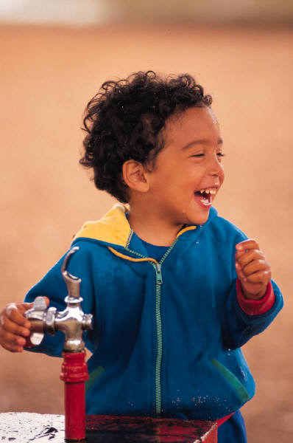

Children are not a vessel to be filled, but a lamp to be lit.

-Hebrew Proverb

*The Teacher’s Role*

**There are five key aspects of the teacher's role:**

1. *Creating a Caring Community of Learners*
2. *Teaching to Enhance Development and Learning*
3. *Planning Curriculum to Achieve Important Goals*
4. *Assessing Children's Development and Learning*
5. *Establishing Reciprocal Relationships with Families*

Our teachers use child observation to guide what it is they need to do with each child. Their observation of each child guides them not only in what the child needs to learn, but also what teaching strategy works best for each child. It is impossible to teach every subject in one way that every child will get at the same time, therefore the teachers present the material in a variety of modes over the entire year. The primary learning modes are auditory, visual and kinesthetic (tactile), and every child has his/her own preferred modality. At the same time, different topics are best presented and taught using these different modalities as well.

Teachers must also adjust their instruction to each child’s unique development. For example, a child who has tremendous fine motor skills and language skills may show they are ready to start learning to read at age 4, so the teacher accommodates instruction to her. Meanwhile, another child may show great proficiency in logical thinking and math, so curriculum is accommodated for her as well. All the while, children are working on all the other skills.

During project work, interest is extended by the teacher as the teacher asks several questions: What is it like? How does it work? How is it connected to other things? How do we know? What is our responsibility? How is it changing over time? Why is it like this? What are the points of view?  Teachers do not always provide the answers for children; rather, children and teachers will learn together, researching, hypothesizing and experimenting as they explore the topic.

As we plan high quality early childhood curriculum, we understand our responsibility to you and to the children’s future that they be “ready” for school. However, what we also understand is that the definition of “ready” does not end with ABC’s and 123’s. Ask any Kindergarten teacher, and she will concur that children need more than that- they need to be problem solvers, good communicators, have good social skills, can think creatively and critically, and have good comprehension skills. Flash cards and ditto sheets do not teach these life skills, so we strive to find a good mix of strategies and approaches that teach ***real*** “readiness skills”.

**The Hundred Languages of Children**

No way.

The hundred is there.

The child is made of one hundred.



The child has

a hundred languages

a hundred hands

a hundred thoughts

a hundred ways of thinking

of playing, of speaking.

A hundred always a hundred ways

of listening,

of marveling,

of loving

a hundred joys

for singing and understanding

a hundred worlds to discover

a hundred worlds to invent

a hundred worlds to dream.

The child has a hundred languages

(and a hundred, hundred, hundred more):

but they steal ninety-nine.

The school and the culture

separate the head from the body.

They tell the child:

to think without hands

to do without head



to listen and not speak

to understand without joy

to love and to marvel

only at Easter and Christmas.

They tell the child:

to discover the world already there

and of the hundred

they steal ninety-nine.

They tell the child:

that work and play

reality and fantasy

science and imagination

sky and earth

reason and dream

are things that do not belong together.

And thus they tell the child that the hundred is not there.

The child says:

No way.

The hundred is there.

--Loris Malaguzzi, founder of the Reggio Emilia, Italy municipal Infant/Toddler and Preschools